Music Store Application

(Based on Django)

Login Information

|  |  |
| --- | --- |
| User id | Password |
| root | root |
| user1 | user1 |
| user2 | user2 |

Screen Shots:-

1. Home page (Browse Songs to add in playlist)

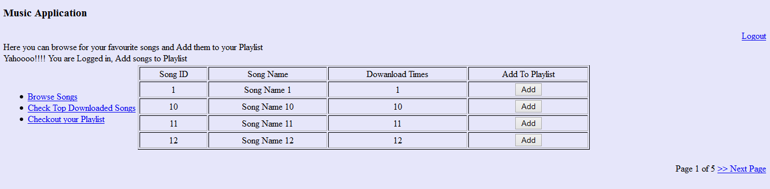

1. Top Downloaded Songs

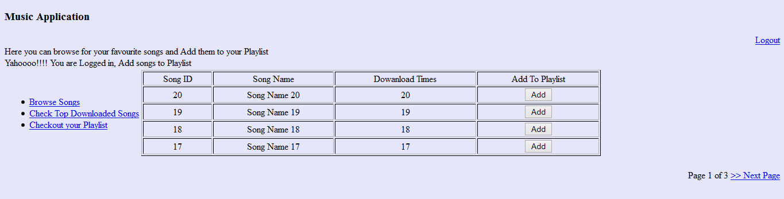

1. Playlist

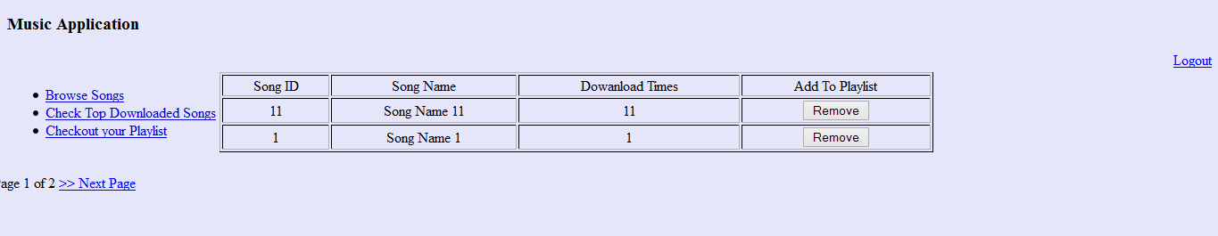

1. Login Screen

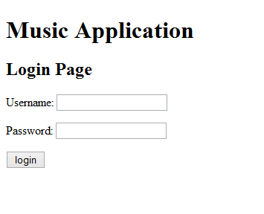

1. Logout Screen

